DATA GURUS MEDICAL FACILITY IMPLEMENTATION SCREENSHOTS

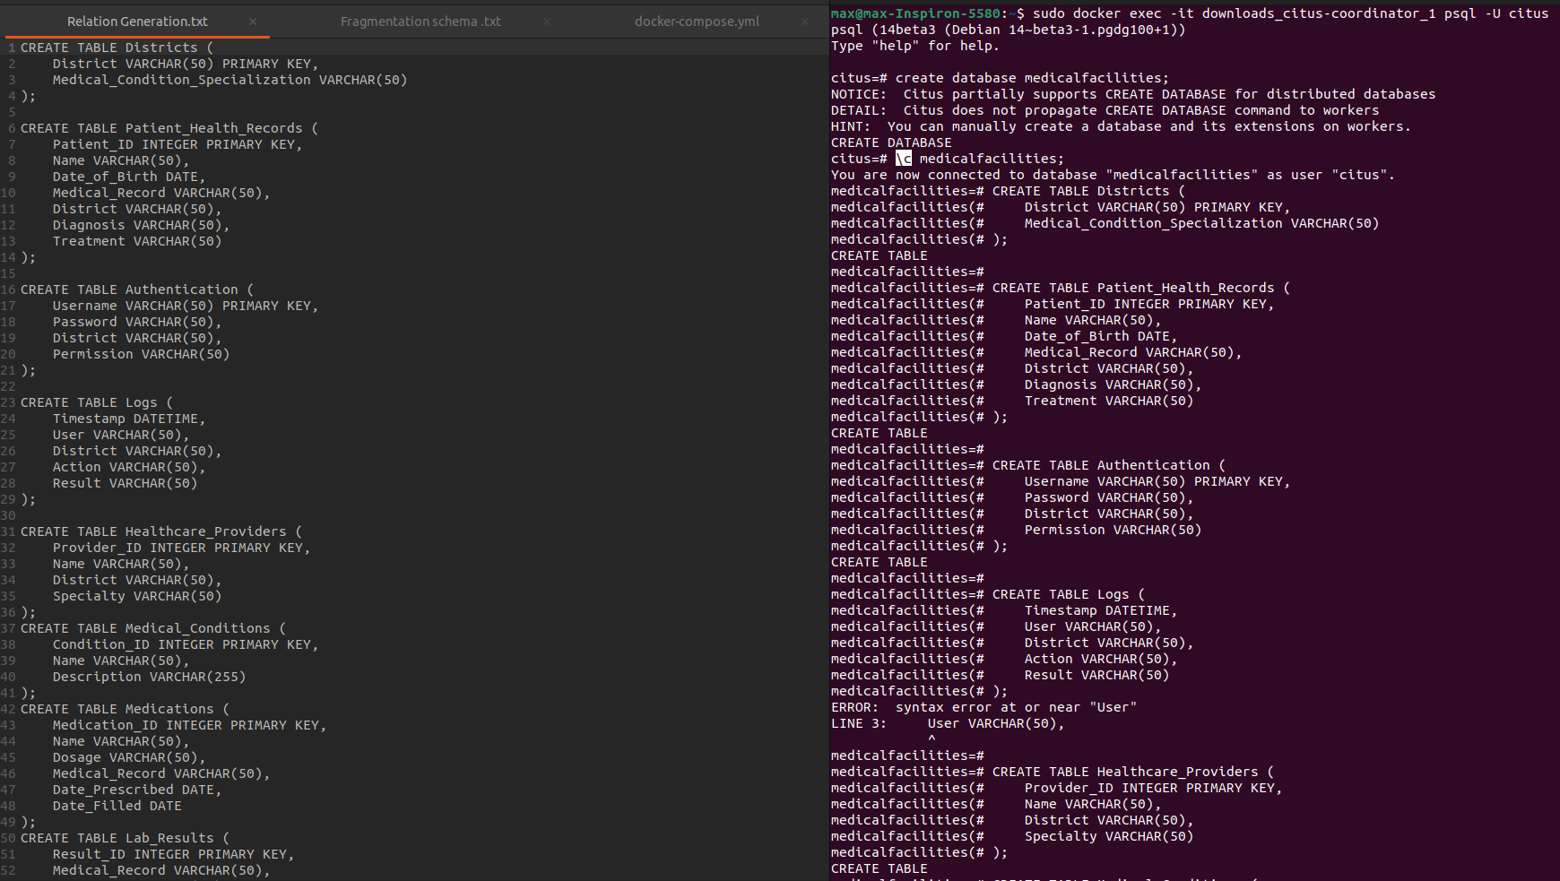
CREATE TABLE

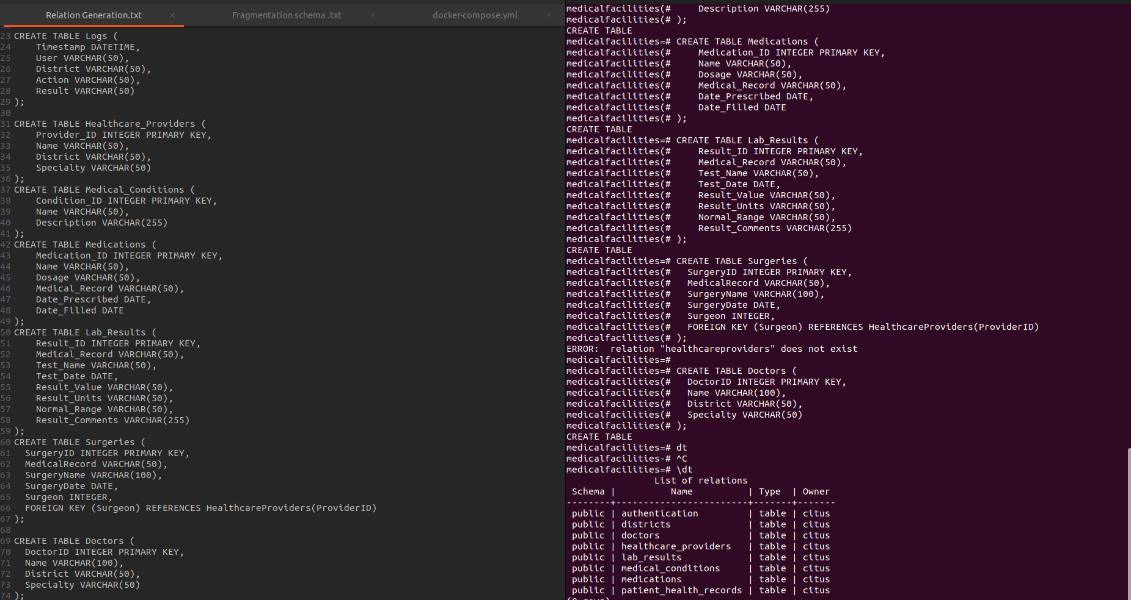
CREATE TABLE, DISPLAY TABLE

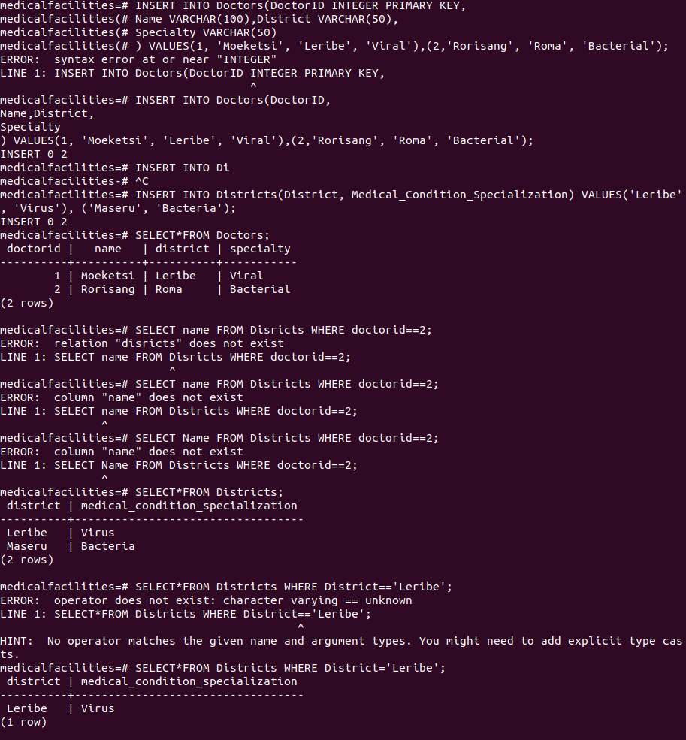
INSERT, SELECT

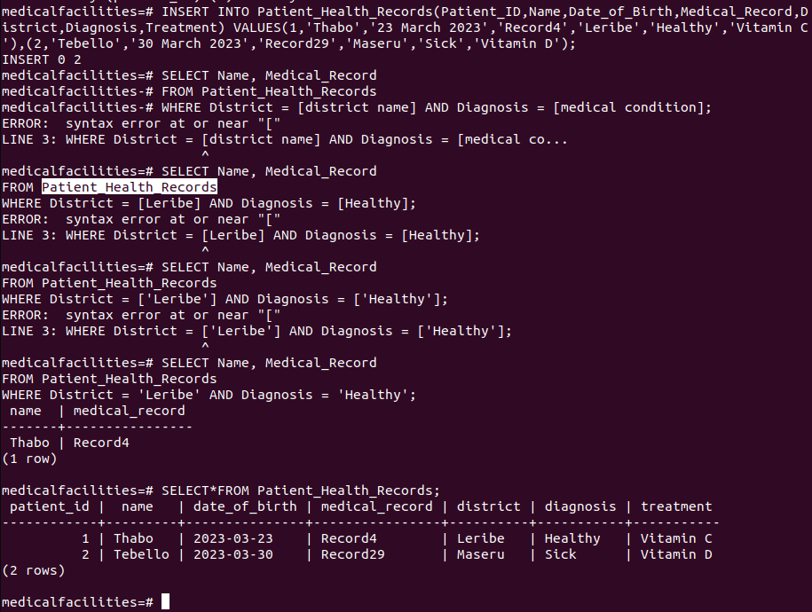
INSERT, SELECT

